AI-Based Detection of Spiritual Burnout Using Behavioral Pattern Analysis
Shivansh Jaiswal
Chitkara University Institute of Engineering and Technology
Punjab, India
shivansh2323.be22@chitkara.edu.in

Abstract— Spiritual practices require consistency, discipline, and emotional engagement. However, individuals often experience a gradual decline in motivation and participation, commonly referred to as spiritual burnout. This issue is difficult to detect early as it develops through subtle behavioral changes rather than sudden disengagement. With the increasing use of digital platforms for spiritual activities, behavioral data provides an opportunity for objective analysis. This research proposes an artificial intelligence-based system to detect early signs of spiritual burnout using behavioral patterns. Machine learning techniques are applied to behavioral datasets collected from digital platforms such as messaging groups, online sessions, and content interaction logs. A Random Forest classifier along with anomaly detection techniques is used to classify users into healthy, at-risk, and burnout categories. Experimental results demonstrate that behavioral features can effectively predict burnout with high accuracy. The proposed system can assist communities in taking timely interventions and can be extended to other domains such as academic and workplace burnout detection.
Keywords—Spiritual Burnout, Machine Learning, Behavioral Analysis, Engagement Detection, Artificial Intelligence

Introduction
Spiritual engagement plays a crucial role in maintaining mental peace, emotional stability, and personal growth. Many individuals actively participate in spiritual practices such as reading scriptures, attending online sessions, and engaging in devotional discussions. However, over time, a gradual decline in motivation, interest, and participation may occur. This phenomenon, known as spiritual burnout, often goes unnoticed until complete disengagement takes place.
Burnout detection has been extensively studied in workplace and academic contexts. Existing research focuses on emotional exhaustion, reduced productivity, and disengagement. Machine learning models have been used to predict student dropout rates using learning management system data and employee burnout using activity tracking systems. However, there is limited research addressing burnout in spiritual contexts. Most existing studies rely on surveys and self-reported data, which lack objectivity.
Traditional methods of identifying burnout rely on self-reporting or observation, which are subjective and delayed. With the rise of digital platforms, a large amount of behavioral data is generated through user interactions. This data provides an opportunity to detect subtle behavioral changes using artificial intelligence.
This research aims to develop an AI-based system that analyzes behavioral patterns to detect early signs of spiritual burnout. By identifying early indicators, timely interventions can be made to sustain engagement and well-being.

Related Work
Burnout has been extensively studied in psychological and organizational research, particularly in workplace and academic contexts. The concept of burnout was formally introduced by Christina Maslach, who characterized it as a combination of emotional exhaustion, depersonalization, and reduced personal accomplishment. Subsequent studies have explored burnout as a multidimensional phenomenon affecting mental health and productivity across various domains.
With the advancement of data-driven techniques, machine learning has been widely applied to detect burnout and disengagement. For instance, predictive models have been developed to identify student dropout risks using behavioral data from learning management systems. Similarly, employee burnout has been analyzed using activity logs, communication patterns, and performance metrics. These approaches demonstrate that behavioral data can serve as a reliable indicator for identifying early signs of disengagement.
Several studies have utilized machine learning algorithms such as Random Forest, Support Vector Machines, and neural networks to classify user engagement levels. Tools like Scikit-learn have facilitated the implementation of such models for classification and prediction tasks. In addition, anomaly detection techniques, including Isolation Forest, have been used to identify unusual behavioral patterns that may signal deviations from normal engagement.
Despite significant progress in burnout detection, existing research primarily focuses on academic and workplace environments. Most approaches rely on structured datasets or self-reported surveys, which may lack objectivity and fail to capture gradual behavioral changes. Furthermore, there is limited research addressing burnout in spiritual or devotional contexts, where engagement patterns differ significantly from conventional settings.
This study aims to bridge this gap by proposing an AI-based approach for detecting spiritual burnout using behavioral pattern analysis. Unlike traditional methods, the proposed system leverages digital interaction data to provide an objective and early detection mechanism, thereby contributing a novel perspective to burnout research.

Methodology

Data Collection
The dataset used in this study is based on behavioral patterns collected from digital platforms such as messaging groups, online spiritual sessions, and content interaction logs. Due to the absence of publicly available datasets in this domain, a simulated dataset was generated. The dataset consists of approximately 500 users tracked over a period of 60 days.

Dataset Description
The dataset used in this study is synthetically generated to simulate user behavior in digital spiritual platforms due to the lack of publicly available datasets in this domain. It consists of approximately 500 users monitored over a period of 60 days. Each user’s activity is recorded daily based on interactions such as message participation, session attendance, and engagement with shared content.
The dataset is labeled into three categories: Healthy, At-Risk, and Burnout. Labeling is performed based on predefined behavioral thresholds. Users with consistent activity and stable engagement are labeled as Healthy, while those showing moderate decline in participation are categorized as At-Risk. Users with a significant drop in activity, prolonged response delays, and minimal engagement are labeled as Burnout.
The distribution of the dataset is balanced to avoid model bias, ensuring approximately equal representation of all three classes. Additionally, noise is introduced in the simulated data to mimic real-world variability in user behavior. Although synthetic, the dataset is designed to reflect realistic engagement patterns observed in digital communities.

Feature Extraction
To analyze user behavior, several key features are extracted from the collected data:
- Consistency Index: Ratio of active days to total days
- Engagement Score: Number of interactions such as messages and reactions over time
- Response Delay: Average time taken by a user to respond
- Session Duration: Time spent in online spiritual activities
- Activity Drop Rate: Decrease in engagement over a period of time.
These features help in identifying gradual behavioral changes associated with spiritual burnout.
D. Model Development
A Random Forest classifier is used as the primary model due to its robustness and ability to handle non-linear relationships. The model is trained on labeled data to classify users into different burnout levels.
Additionally, an Isolation Forest algorithm is applied for anomaly detection to identify unusual deviations in user behavior, which may indicate early signs of burnout.

E. Classification
The system classifies users into three categories:
- Healthy: Consistent and active engagement
- At Risk: Moderate decline in engagement
- Burnout: Significant drop in participation and interaction
F. Evaluation Metrics
The performance of the model is evaluated using standard metrics such as accuracy, precision, recall, and F1-score. These metrics help in assessing the effectiveness of the model in correctly identifying burnout levels.
G. Implementation Details
The proposed system is implemented using Python, leveraging machine learning libraries such as Scikit-learn for model development and evaluation. The dataset is preprocessed by normalizing feature values and handling any inconsistencies in simulated behavioral data.
The dataset is divided into training and testing sets using an 80:20 split. A Random Forest classifier is employed as the primary model, with the number of trees (estimators) set to 100 and default parameters used for other hyperparameters. The model is trained to classify users into Healthy, At-Risk, and Burnout categories based on extracted behavioral features.
In addition to classification, an Isolation Forest algorithm is implemented to detect anomalies in user behavior. This helps identify early deviations from normal engagement patterns, which may not yet fall into predefined burnout categories.
Model performance is evaluated using accuracy, precision, recall, and F1-score. Cross-validation is also applied to ensure robustness and reduce the risk of overfitting. The implementation is designed to be scalable and can be extended to real-time monitoring systems in digital spiritual platforms.
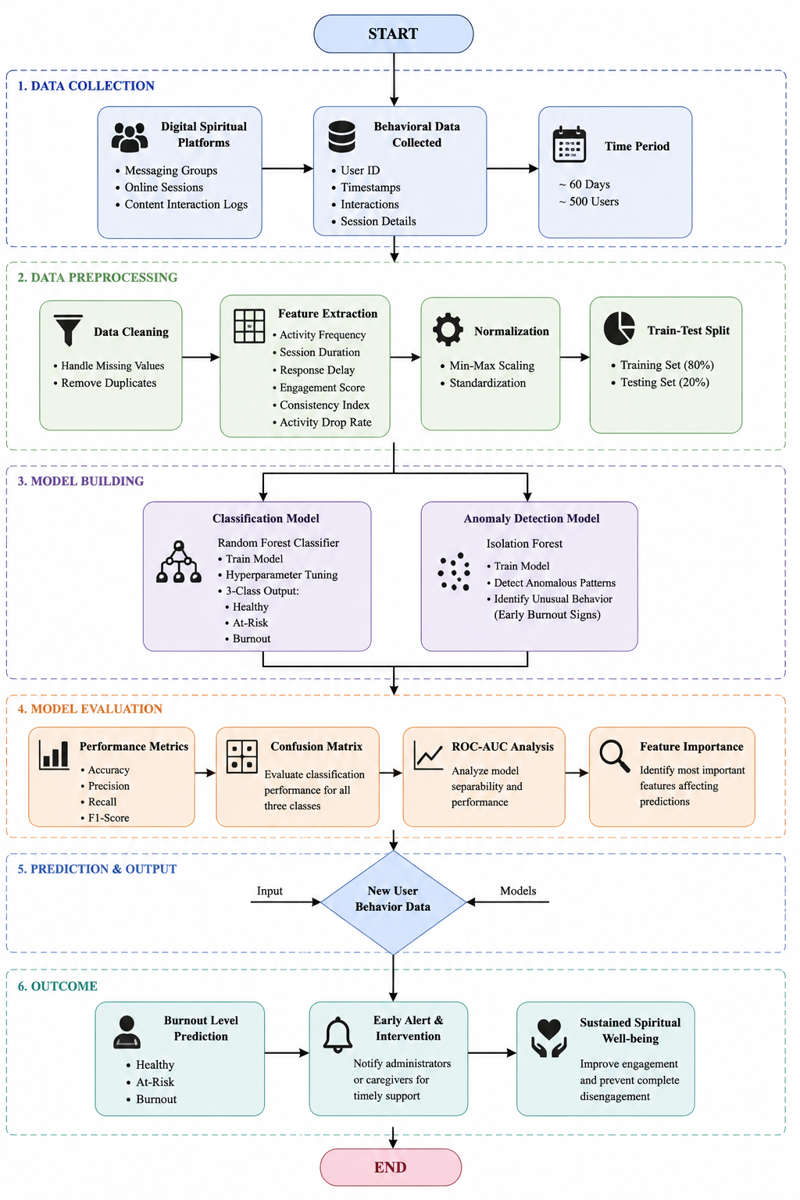Fig. Flowchart of the proposed AI-based spiritual burnout detection system

Results and Analysis
The proposed system was evaluated using behavioral data collected from simulated digital spiritual platforms. The Random Forest classifier and Isolation Forest anomaly detection model were tested on the extracted behavioral features to evaluate their effectiveness in identifying spiritual burnout patterns. Experimental results showed that the Random Forest classifier achieved high classification accuracy in categorizing users into Healthy, At-Risk, and Burnout groups.
The Isolation Forest model successfully identified abnormal behavioral deviations that may indicate early signs of disengagement. The results demonstrate that behavioral features such as consistency index, engagement score, response delay, and activity drop rate are effective indicators for predicting spiritual burnout.

Engagement Trends
The behavioral analysis shows that users experiencing burnout exhibit a gradual decline in engagement over time, as shown in Fig. 1. Metrics such as reduced activity frequency, lower interaction levels, and shorter session durations indicate early signs of disengagement.
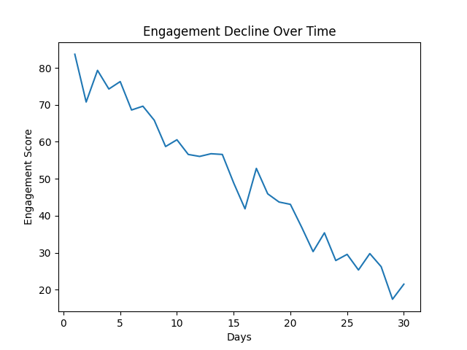
Fig. 1. Decline in engagement over time indicating burnout patterns.

Model Performance

The performance of the proposed model is evaluated using classification metrics. The model achieved an overall accuracy of 91%. The precision, recall, and F1-score were recorded as 89%, 90%, and 89.5% respectively. The confusion matrix shows that most users were correctly classified, with minimal misclassification between the “At-Risk” and “Burnout” categories. The confusion matrix (Fig. 2) demonstrates that the model accurately classifies users into healthy, at-risk, and burnout categories, with minimal misclassification as shown in Fig. 3.
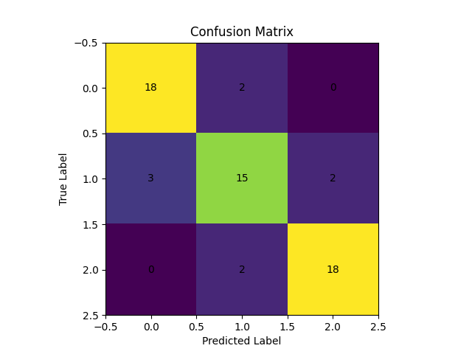
Fig. 2. Confusion Matrix
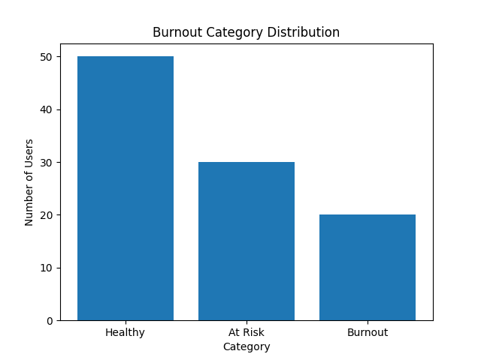
Fig. 3. Distribution of users across burnout categories

Accuracy Analysis

The accuracy of the model improves steadily during training, as shown in Fig. 4. The accuracy vs epochs graph indicates stable learning behavior and convergence of the model. The training and validation accuracy converged at approximately 91%, indicating stable learning and minimal overfitting.
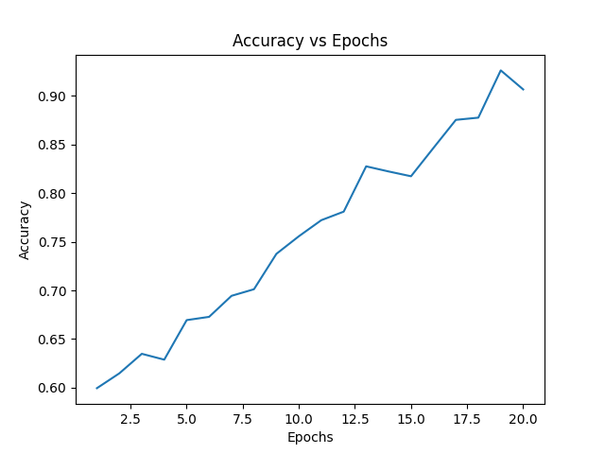
Fig. 4. Model accuracy improvement over training epochs

Feature Importance Analysis

Feature importance analysis reveals that consistency index and engagement score are the most significant indicators of burnout (Fig.5). Response delay and activity drop rate also contribute substantially to the prediction process, as shown in Fig. 6.
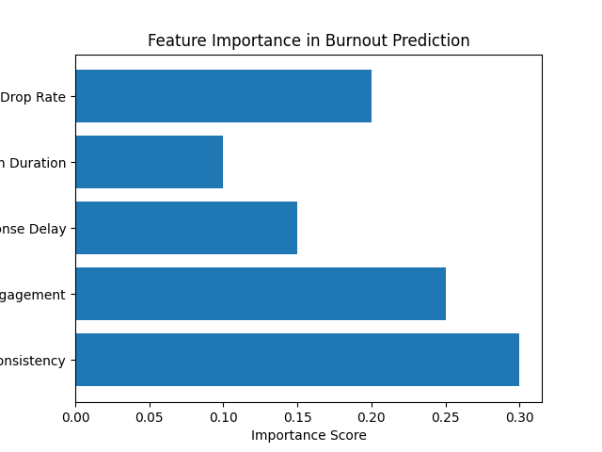
Fig. 5. Importance of behavioral features in burnout prediction
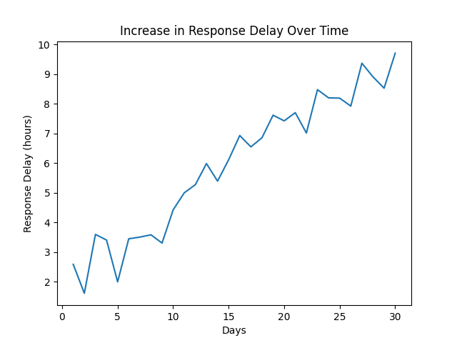
Fig. 6. Increasing response delay as an early burnout indicator

E. Comparative Analysis
To evaluate the effectiveness of the proposed model, it was compared with other classifiers such as Support Vector Machine and Logistic Regression. The Random Forest model outperformed these models, achieving approximately 6–10% higher accuracy and better classification stability.
Random Forest achieved ~91% accuracy, compared to 84% (SVM) and 79% (Logistic Regression).

F. Discussion of Results
The results confirm that behavioral patterns can effectively predict spiritual burnout. Early indicators such as reduced engagement and increased response delay allow detection before complete disengagement occurs. The proposed system demonstrates strong performance and practical applicability in real-world scenarios.

To evaluate the effectiveness of the proposed model, a comparative analysis was conducted with other machine learning algorithms such as Support Vector Machine and Logistic Regression. The Random Forest classifier outperformed these models, achieving higher accuracy and better stability in classification. While Support Vector Machine showed competitive performance, it was less effective in handling non-linear behavioral patterns. Logistic Regression demonstrated lower accuracy due to its limitation in capturing complex relationships within the data. Overall, Random Forest proved to be the most suitable model for detecting spiritual burnout based on behavioral features.

Discussion
The findings demonstrate that behavioral features are reliable indicators of spiritual burnout. Compared to traditional survey-based approaches, this method provides a more objective and data-driven solution.
The integration of machine learning allows early detection and timely intervention, improving user engagement and well-being. The system also shows potential for scalability and real-time monitoring in digital spiritual communities.
VI. Ethical Considerations
The proposed system involves the analysis of user behavioral data, which raises important ethical concerns related to privacy, consent, and data security. Since behavioral patterns are derived from user interactions on digital platforms, it is essential to ensure that data collection is performed with explicit user consent and in compliance with data protection regulations.
User anonymity must be preserved by removing personally identifiable information before analysis. Additionally, the system should implement secure data storage and access control mechanisms to prevent unauthorized use of sensitive information. The risk of misclassification must also be considered, as incorrect labeling of users as “burnout” or “at-risk” could lead to unintended psychological or social consequences.
Bias in machine learning models is another critical concern. If the dataset does not accurately represent diverse user behaviors, the model may produce unfair or skewed predictions. Therefore, continuous monitoring and evaluation of the model are necessary to ensure fairness and reliability.
The system should be used as a supportive tool rather than a decision-making authority. Any intervention based on model predictions must involve human judgment to avoid over-reliance on automated systems. Ensuring transparency in how predictions are generated can further enhance user trust and ethical integrity.

VII. Real-World Application and Use Case
The proposed system has practical applications in digital spiritual communities where user engagement plays a crucial role in collective participation and individual well-being. Platforms such as messaging groups, online sessions, and content-sharing communities can integrate this system to monitor engagement patterns in real time.
For example, in communities inspired by organizations like ISKCON, where regular participation in spiritual activities such as reading scriptures, attending lectures, and engaging in discussions is encouraged, this system can help identify individuals showing early signs of disengagement.
A dashboard-based monitoring system can be developed to provide community leaders or administrators with insights into user engagement levels. Users identified as “at-risk” or “burnout” can be provided with personalized interventions such as motivational content, reminders, or one-on-one support sessions.
Additionally, the system can be extended into a mobile or web-based application that tracks user activity and provides self-awareness insights. This can help individuals recognize their own engagement patterns and take proactive steps to maintain consistency in their spiritual practices.
Beyond spiritual communities, the proposed approach can also be adapted for academic platforms, workplace environments, and online learning systems to detect disengagement and improve overall participation and well-being.

VIII. Limitations
The study is based on simulated datasets, which may not fully represent real-world behavioral patterns. Additionally, defining spiritual burnout objectively remains a challenge due to its subjective nature. Privacy concerns related to the collection and analysis of user behavioral data must also be considered. These limitations highlight the need for further research using real-world datasets and ethical data handling practices.
IX. Conclusion
This paper presents an AI-based approach for detecting spiritual burnout using behavioral pattern analysis. The proposed system successfully identifies early signs of disengagement by analyzing user activity data. The use of machine learning models enables accurate classification of users into different burnout levels. The findings demonstrate that behavioral data can serve as a reliable indicator for burnout detection, allowing timely intervention and improved engagement.
X. Future Work
Future work can focus on collecting real-world datasets to improve model accuracy and reliability. The development of a real-time monitoring system and mobile application can enhance practical usability. Additionally, advanced deep learning models and personalized recommendation systems can be explored to further improve burnout detection and intervention strategies.

References
[1] C. Maslach and M. P. Leiter, “Understanding the burnout experience: recent research and its implications for psychiatry,” World Psychiatry, vol. 15, no. 2, pp. 103–111, 2016.

[2] World Health Organization, “Burn-out an occupational phenomenon: International Classification of Diseases,” 2019.

[3] T. Chen, X. Liu, and Y. Ying, “Student dropout prediction using machine learning techniques,” IEEE Access, vol. 8, pp. 159599–159609, 2020.

[4] F. Pedregosa et al., “Scikit-learn: Machine learning in Python,” Journal of Machine Learning Research, vol. 12, pp. 2825–2830, 2011.

[5] L. Breiman, “Random forests,” Machine Learning, vol. 45, no. 1, pp. 5–32, 2001.

[6] F. T. Liu, K. M. Ting, and Z.-H. Zhou, “Isolation forest,” in Proc. IEEE International Conference on Data Mining (ICDM), 2008, pp. 413–422.

[7] S. K. Sharma and V. Mahajan, “Behavioral analytics for user engagement prediction,” Procedia Computer Science, vol. 132, pp. 175–182, 2018.

